A Visit to the Zoo (form 3)
A binary lesson of English and extracurricular reading
Worksheet 1: Pre-Zoo Activity
Name: ________________________ Date: ________________________
Exercise 1
Instruction for the teacher: revise the names of colours and body parts, special question structure, the forms of “to be”.
- What colour is / are the monkey’s (body, feet, legs, tail, hands, ears, eyes, nose and mouth)?
- What are we not going to colour? – The banana, the stick.

Colour the monkey!
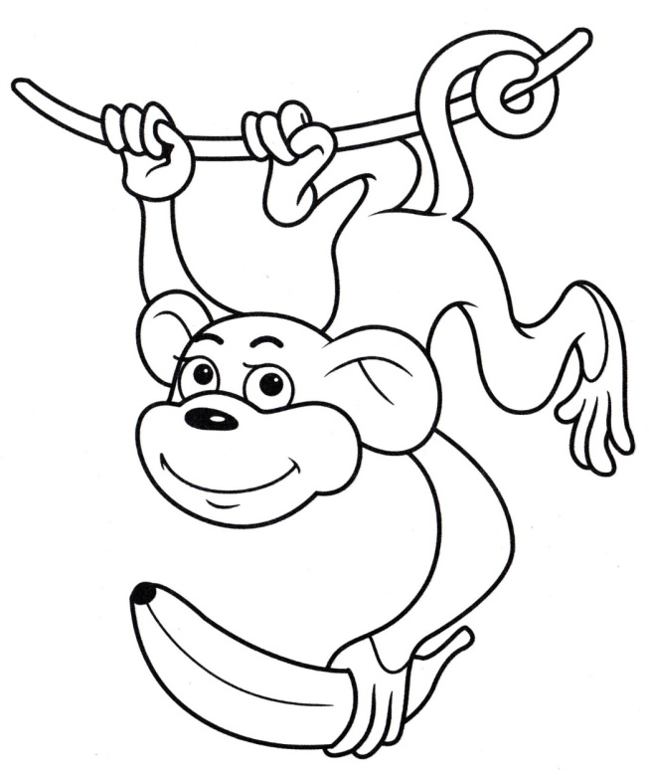
Exercise 2
Match the words and the pictures.
a monkey | 
bananas | 
a tree | 
an apple | 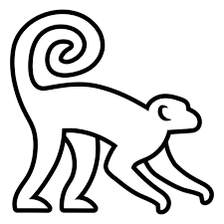
a rope | 

Exercise 3
Circle the names of animals we can see at the Moscow Zoo.

Instruction for the teacher:
The pupils get the information for this task from the Moscow Zoo website https://zoo.mos.ru/. Use the electronic board.

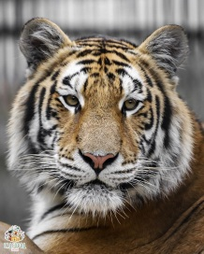 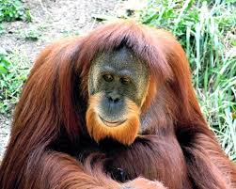 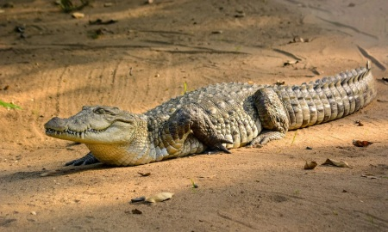
Tiger Orangutan Crocodile

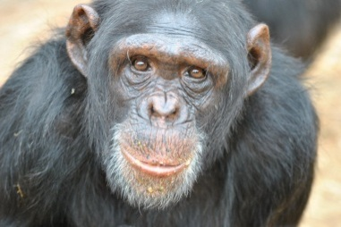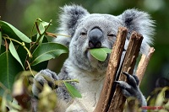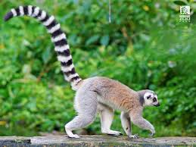
Chimpanzee Koala Lemur
Exercise 4
We read together.
Instruction for the teacher: at an extracurricular reading lesson pupils read the story in Russian, discuss it, and draw conclusions about what it teaches.

Conclusions:
1. Responsibility for your pet.
2. Humane treatment of animals.
3. Not every animal can be kept as a pet.
4. Understanding the needs of animals.
5. We are responsible for those we have tamed.

English lesson: learning new vocabulary, improving pronunciation and grammar skills. Pay attention to the highlighted words – introduce them before reading the story.

A Mischievous Monkey
This story is about a kind boy who loves animals. One day, his friend gives him a little monkey. It is a macaque named Yasha.
Yasha is very clever and curious. He has got reddish fur, black hands and feet, and bright, lively eyes. His face is wrinkled and looks very old.
But Yasha is also very mischievous! He is always active and gets into trouble. He hides things, jumps. runs and makes a mess of rooms. Life with him is never boring! Also, he needs a lot of fruit, like bananas and apples, and can bite if he is angry.
The boy tries to take care of Yasha. But he learns his lesson: you can have difficulties even with the animals you love. They may have their own habits and this may be a problem.
To have a pet is more than just to love it. It is to understand what it needs and respect its nature. You must be ready for the challenges that come with a pet.
Answer the questions:
1. Who gives the boy a monkey?
2. What is the monkey's name? What kind of monkey is he?
3. What colour are the monkey's hands and feet?
4. What does the monkey like to do? (Name one mischievous thing)
5. What is the main lesson the boy learns?
Answer keys:
1. His friend does.
2. The monkey’s name is Yasha, he is a macaque.
3. The hands and feet are black.
4. He likes to hide things, run and jump. It needs a lot of fruit.
5. To have a pet is to love it, to understand its needs, and to be ready for challenges.

Exercise 5 (Задание 5)
Study the rules of conduct at the zoo. Match the English descriptions and the Russian explanations and signs. Some descriptions have more than one matches, some don’t have any.

Zoo Rules for Super Kids
A trip to the zoo is so much fun! Let's be great visitors and keep the animals safe and happy. Here's how:
A. Just walking, no running or climbing!
Walk, don't run. Running can scare (= напугать) the animals. Let's be calm and quiet for them. Don’t try to get into animals’ homes!
B. Be quiet!
Talk softly. Loud noises are scary for animals. You may take photos, but don’t use a flashlight.
C. Look with your eyes, not with your hands!
Do not feed the animals. Human food can make them very sick. Do not throw anything into the animal homes. Keep your hands off the glass and fences.
D. Listen to the grown-ups!
Stay with your group. Always stay where they can see you. The zoo is a big place!
E. Keep the place clean!
Put your trash in the bin. Let's keep the zoo clean for the animals and other visitors.
F. Be friendly!
Take turns at the cages so that everyone can see the animals.
Have a wonderful time learning about amazing animals!
____________________________________________________________
В зоопарке нельзя:
1.Кормить животных.
2.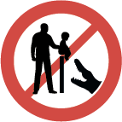Перелезать через ограничительные барьеры.
3.Бросать в вольеры посторонние предметы.
4.Просовывать руки сквозь решетки и сетки вольеров.
5.Стучать по стеклам вольеров, кричать рядом с ними, дразнить животных.
6.Фотографировать животных со вспышкой.
7.Мусорить на территории зоопарка, обрывать зелень с деревьев, газонов, ходить по газонам.

A | B | C | D | E | F
2 | 5, 6 | 1, 3, 4 |  | 7

Worksheet 2: A Visit to the Zoo
Name: ________________________ My Team: ___________________
Instructions for the teacher:
Where to find information?
1) The Zoo emblem: the Pallas’s cat is depicted on the emblem above the main gates of the Moscow Zoo, immediately indicating its status as a symbol.
2) Information boards.

We draw pupils’ attention to the zoo emblem above the entrance as we start our visit. The English for «манул» is Pallas’s cat - Peter Simon Pallas, a German and Russian scientist, first wrote about this animal in 1776.
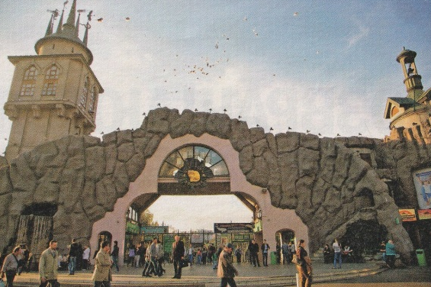
Exercise 1
Tick  the true/false rules of visiting the Zoo.
Zoo rules | True | False
Walk, don’t run.
Speak in a loud voice.
Look with your eyes, not with your hands.
Don’t listen to the grown-ups.
Be tidy.
Don’t be friendly.
Ride a bike or a scooter.

Exercise 2
Find the Moscow Zoo map and take a look at it.
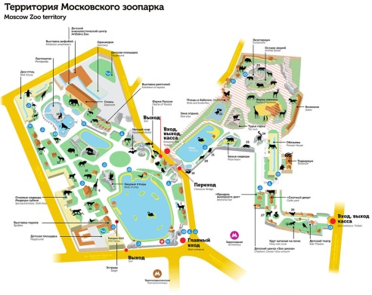
- Find where you are.
- Find the Pallas’s cat’s home at the zoo.
- Where is the Monkey Pavilion located? Choose the correct answer:
1. The old territory.
2. The new territory.
3. There is no such pavilion at the zoo.

Match the sign with its name.

  or | Route
or | I’m here

Exercise 3
Use the map of the zoo.
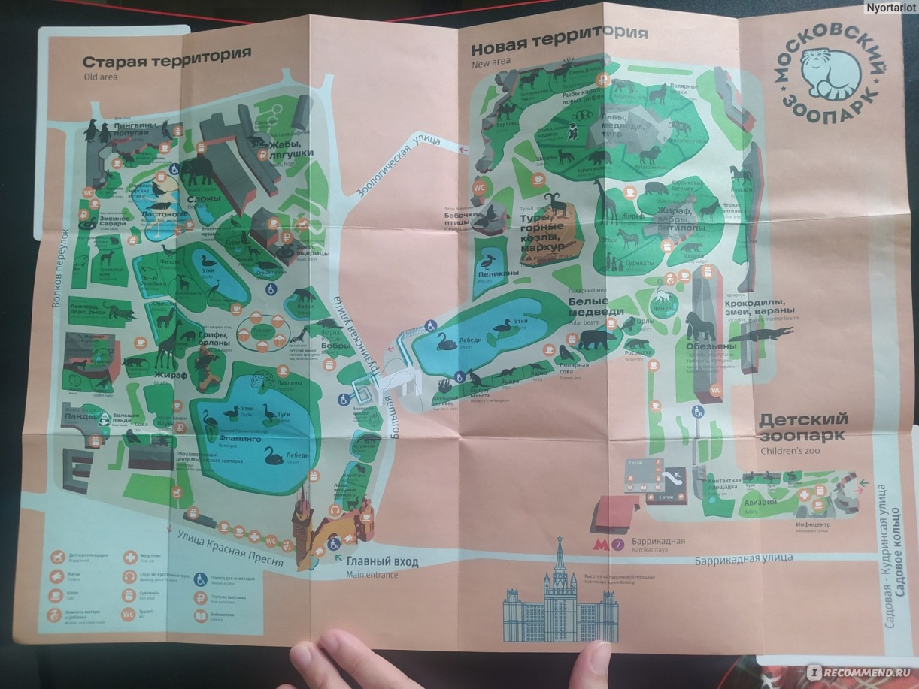

- Find your way to the Monkey Pavilion.
- What animals will you see on your way? Write down their names.
____________________________________________________________
____________________________________________________________
- Are these wild or domestic animals? ____________________________________________________________
____________________________________________________________

Exercise 4
Let’s go to the Monkey Pavilion!
Fill in the table.
The name of the monkey | I see it | Today it is…
The name of the monkey |  | active | calm | sleepy
Orangutan
(Орангутан)
Diana monkey
(Мартышка диана)
Gorilla
(Горилла)
Lion-tailed macaque
(Львинохвостый макак)
Eastern colobus
(Восточный колобус)
Mandrill
(Мандрил)
Capuchin monkey
(Капуцин)
Gibbon
(Гиббон)
Tamarin monkey
(Тамарин)

- What can you see in their cages?
____________________________________________________________
____________________________________________________________
- What do these monkeys like? Study the information boards and write 2-3 words.
____________________________________________________________
____________________________________________________________

Exercise 5
Write the names of the monkey’s body parts.
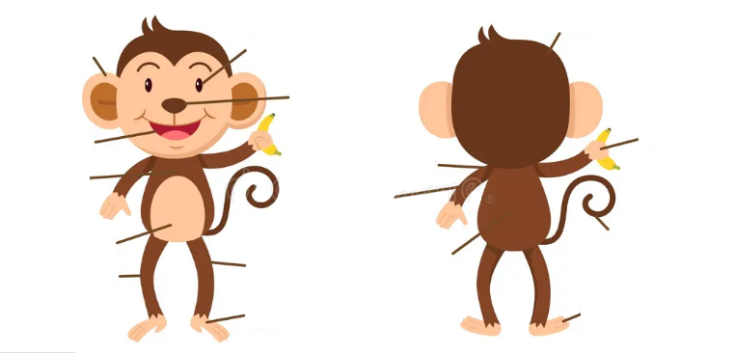

Answer Keys
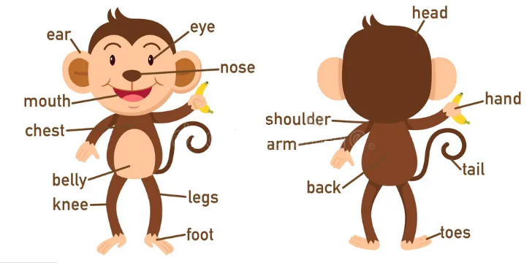

Exercise 6
Complete an email to a friend. Fill in the gaps. Choose the right punctuation marks.

Instructions for the teacher:
Teaching pupils to read instructions correctly and follow the format in the “Writing” section is a necessary step in gradually preparing pupils for examinations.
Dear _______________ (friend’s name) ! / ,
Today I have been to _________________________________________.
I have seen _________________________________________________.
My favourite animal is the ______________________________________.
It is ________________________________________________________.
It likes _____________________________________________________.
I also like other animals: _______________________________________.
Please write back soon.
Your friend . / ,
_______________

Worksheet 3: Post-Zoo Activity
Name: ________________________ Date: ________________________
Instructions for the teacher.
Лексическое повторение
The teacher says:
Does a cat have ears? – Yes, it does. / No, it doesn’t.
Show me your ears! – дети показывают на свои уши.
Touch your dog’s nose – дети касаются своего носа
Does a dog have wings? – Yes, it does. / No, it doesn’t.
Animals – tiger, rabbit, orangutan, bird, fox, monkey, elephant, gorilla, etc.
Body parts – head, ears, eyes, nose, mouth, paws, wings, tail, feet, etc.

Речевая разминка
1. Answer my questions:
- Have you got a pet?
- What pet have you got?
- What is its name?
- What colour is your pet?
- Is your pet big or little?
- Do you like to play with your pet?

2. Prepare cards with animal and colour names. The pupil draws one card of each type and makes a complete sentence: “It is a blue fish” or “I see a brown dog”. The other pupils answer: TRUE or FALSE.
3. Remember and answer “Yes” or “No”.
- Do you see a big gorilla? – Yes, I do. I also see … / No, I don’t, but I see…
- Do rabbits eat bananas? – Yes, they do. They also eat … / No, they don’t, they eat…
- Is the orangutan funny? – Yes, it is. It is also … / No, it isn’t. It is …
- etc.
4. Finish the sentence.
My favorite monkey is the … (gorilla / orangutan / chimpanzee / lemur).
It is … (big / small / funny / sleepy).
etc.
Project work: draw your animal!

Name your animal: ____________________________________________
What does it eat? _____________________________________________
What does it like to do? ________________________________________

Instructions for the teacher: a pupil shows his drawing and gives a description of the animal. Other pupils fill in the table.

Fill in the table.

Your name __________________________________________________

Pupil’s name | Animal’s name | Colour, size | It eats… | It likes to…
Anna | chimpanzee | small  brown | bananas | jump  climb

